BA710

Winter 2024 Case

20 Marks

Due Monday April 8, 2024

**Deliverable details:**

Complete all questions in this Word document.

Complete the SQL template.

Your source data must be loaded to a schema called BA710case.

Your work data must be loaded to a schema called Work.

Your work tables must include “case_” as a prefix to the table name you choose.

**Premise:**

You work at a company that manufactures and sells electric scooters. You have been told that the pre-orders for the Bat Scooter were initially good, but the orders suddenly dropped by 20%.

Your job is to investigate the situation and test some general hypotheses on why this might have occurred, post hoc.

Since our company headquarters is in Toronto, we need to make sure your dates are stored in Eastern time. The easiest way to do this is to set the time zone in the top of your code:

**/*Set Time Zone*/**

**set time_zone='-4:00';**

**Part 1:**

**Example Sales Analysis for the Blade Scooter:**

Percentage growth in cumulative_sales from 6/23 to 6/30

Total sales 7/2 – 7/8

Total sales 6/23 – 6/29

Counts up for each record

Percentage growth in cumulative_sales from 7/8 to 7/1

(63559 – 39899) /39899 = 59.29

**Paste your Bat Sales Analysis table:**

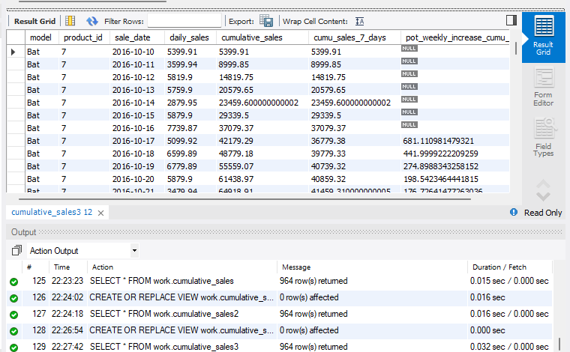

Question: On what date does the cumulative weekly sales growth drop below 10%?

Answer: December 6, 2016.

Question: How many days since the launch date did it take for cumulative sales growth

to drop below 10%?

Answer: 57 days.

**Paste your Bat Limited Sales Analysis table:**

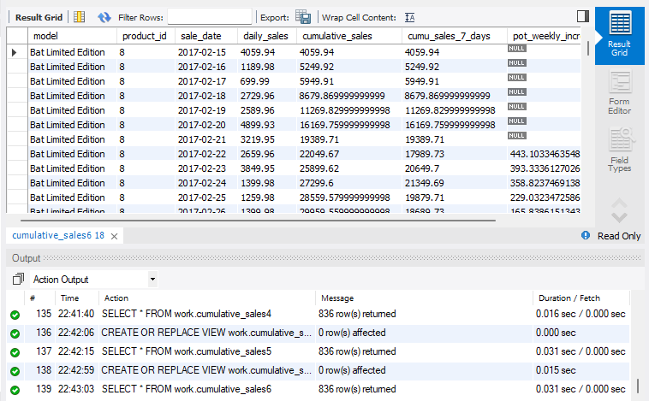

Question: On what date does the cumulative weekly sales growth drop below 10%?

Answer: April 29, 2017.

Question: How many days since the launch date did it take for cumulative sales growth

to drop below 10%?

Answer: 73 days

Question: Is there a difference in the behavior in cumulative sales growth

between the Bat edition and the Bat Limited edition? (Make a statement comparing

the growth statistics.)

Answer: Comparing cumulative sales growth between the Bat model and the Bat Limited Edition model reveals the latter's better performance. While the Bat model dropped below 10% in 57 days, the Bat Limited Edition model took 73 days. However, for a fair comparison, data from February 15, 2017, to May 31, 2019, is considered to avoid skewing the analysis due to additional sales data for the Bat model from October 10, 2016, to February 14, 2017.

**Paste your Lemon 2013 Sales Analysis table:**

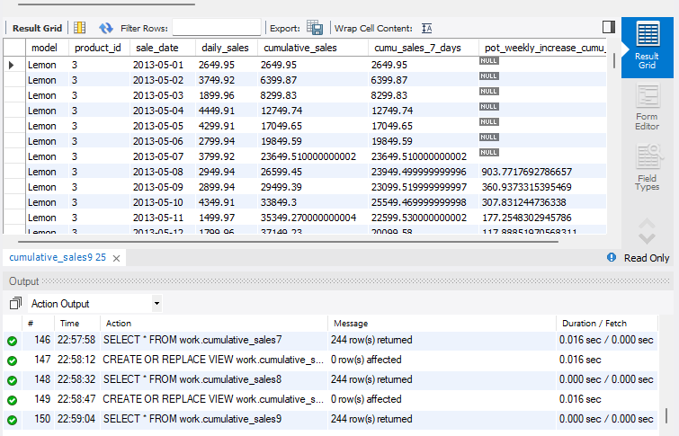

Question: On what date does the cumulative weekly sales growth drop below 10%?

Answer: July 1, 2013

Question: How many days since the launch date did it take for cumulative sales growth

to drop below 10%?

Answer: 61 days

Question: Is there a difference in the behavior in cumulative sales growth

between the Bat edition and the 2013 Lemon edition? (Make a statement comparing

the growth statistics.)

Answer: To compare cumulative sales growth between the Bat model (data from October 10, 2016, to May 31, 2019) and the 2013 Lemon model, only sales data from October 10 to December 31 is considered for each product's respective year. Analysis reveals a decline in cumulative sales for both models: the Lemon model drops below 10% for the first time on July 1, 2013, continuing until December 31, 2013. Similarly, the Bat model's cumulative sales drop below 10% from December 6 to December 31, 2016. This suggests a parallel behavior in cumulative sales growth between the Bat model and the 2013 Lemon model.

**Part 2:**

**Coming week 7.**